Final Paper Topic (SAMPLE) Should be artworks created after 1300 AD

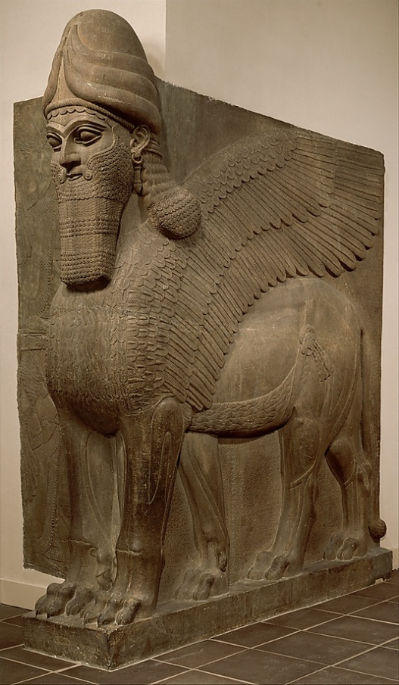
Human-headed winged bull and winged lion (lamassu)
Period: Neo-Assyrian
Date: ca. 883–859 B.C.
Geography: Mesopotamia, Nimrud (ancient Kalhu)
Culture: Assyrian
Medium: Gypsum alabaster
Dimensions: H. 10 ft. 3 1/2 in. (313.7 cm)
Classification: Stone-Reliefs-Inscribed
Credit Line: Gift of John D. Rockefeller Jr., 1932
Accession Number: 32.143.1–2
This artwork is currently on display in Gallery 401

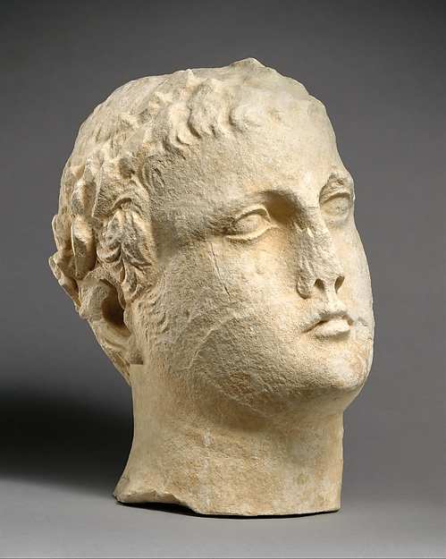
Limestone head of beardless male votary with wreath of leaves
Period: Hellenistic
Date: early 2nd century B.C.(?)
Culture: Cypriot
Medium: Limestone
Dimensions: Overall: 12 x 7 1/2 x 10 in. (30.5 x 19.1 x 25.4 cm)
Classification: Stone Sculpture
Credit Line: The Cesnola Collection, Purchased by subscription, 1874–76
Accession Number: 74.51.2805
This artwork is currently on display in Gallery 176

Write here about what about the two artworks interested you, and why you have chosen them for your comparison.

[ATTACH YOUR ADMISSION RECEIPT TO THE METROPOLITAN MUSEUM OF ART]

